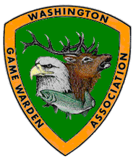
W.G.A.
WHAT COMES WITH BEING AN ASSOCIATE MEMBER?
All Associate Members receive the following upon payment of the membership donation:
* WGA membership card
* Subscription to – WDFW's Statewide Case & Update Publication via E-mail
* Subscription to- International Game Warden Magazine * A WGA baseball cap of your choice
* Associate memberships are available for $30 per year.

ASSOCIATE MEMBERSHIP APPLICATION
NAME / COMPANY ________________________________________

ADDRESS: _________________________________________________

CITY _____________________ STATE _________ ZIP:___________
PHONE: (______)__________________
E-mail address_____________________________

Signature:_______________________________ Date: _________________

*Payments to WGA are NOT tax deductible as charitable contributions for federal income tax purposes.

Please enclose your check or money order payable to:
Washington Game Warden Association
c/o Brandon Chamberlin
2310 NW 379th Street La Center WA 98629

